40.57: a)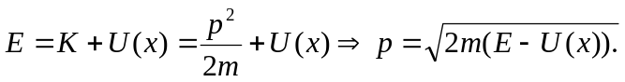
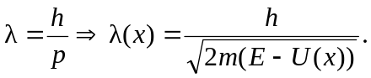
b) As from below—recall
c)
d) 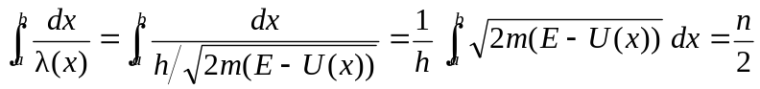
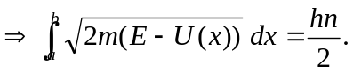
e)
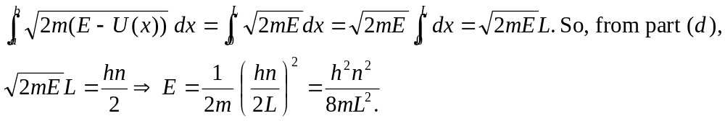
f) Since 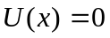 in the region between the turning points at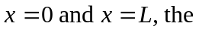results is the same as part (e). The height 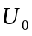 never enters the calculation. WKB is best used with smoothly varying potentials 